Date: November 10, 2021

Chief Regulatory Officer
Dhaka Stock Exchange Ltd.
Stock Exchange Building
9/F, Motijheel C/A.
Dhaka –1000.

Subject: Meeting of the Board of Directors of Rahima Food Corporation Ltd. for consideration of the Un-audited 1st quarter Financial Statements of the company for the Quarter ended on 30th September, 2021.

Dear Sir,

Please refer to our letter, dated 04 November, 2021 and kindly be informed that for un-avoidable circumstances the meeting of the Board of Directors of Rahima Food Corporation Ltd. for the above purpose will be held on 13th November, 2021 at 3:00 pm instead of 10th November, 2021.

Thanking you.

Yours truly,
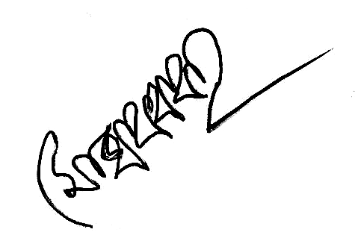
(Md. Zakir Hossain)
Company Secretary

Copy to : Executive Director, BSEC.

